Lab No. 05 & 06

STL Sequential &

Customized Generic Container:

List Tasks
Task 1: Find Maximum [4+4+2=10]
Create an integer type list of size 500 and populate this list. Use this list for following subtasks.
- Write a function which returns the maximum value of the passed list. Its prototype would like as follows;
int list_max(list <int> &ls);

Code:
#include <iostream>
#include <list>
using namespace std;

int list_max(list<int>& ls)
{
int max;
list<int>::iterator it = ls.begin();
max = *it;
for (it = ls.begin(); it != ls.end(); it++)
{
if (*it > max)
{
max = *it;
}
}
return max;
}
- Write a function which adds index position of the passed list in the existing values of this passed list.
void list_seq_num(list <int> & ls);
void list_seq_num(list<int>& ls)
{
int index = 0;
list<int>::iterator it;

for (it = ls.begin(); it != ls.end(); it++)
{
*it = *it + index;
index++;
}
}
- Test these functions by making call to them in a main() function.
int main()
{
list<int> ls;
for (int i = 0; i < 500; i++)
{
ls.push_back(i + 1);
}
int maxValue = list_max(ls);
cout << "max value" << maxValue << endl;

list_seq_num(ls);

cout << "update list";
list<int>::iterator it;
int count = 0;

for (it = ls.begin(); it != ls.end(); it++)
{
cout << *it << " ";
count++;

if (count == 10)
break;
}
return 0;
}
Output:
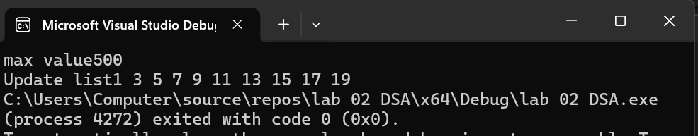
Task 2: Tricky List Printing [10]
You are given two lists, firstList and secondList, containing integers sorted in ascending order. The operation printLots(firstList, secondList) will print the elements in firstList that are in positions specified by secondList. For instance, if secondList = 1, 3, 4, 6, the elements in positions 1, 3, 4, and 6 in firstList are printed.
Write the function printLots(firstList, secondList) to perform the above algorithm. Use only the public STL list container operations.
Code:
#include <iostream>
#include <list>
using namespace std;

void printLots(list<int>& firstlist, list<int>& seclist)
{
list<int>::iterator it1;
list<int>::iterator it2;
int index = 0;
it1 = firstlist.begin();
it2 = seclist.begin();
while (it1 != firstlist.end() && it2 != seclist.end())
{
if (index == *it2)
{
cout << *it1 << " ";
it2++;
}
it1++;
index++;
}
}
int main()
{
list<int> firstList;
list<int> seclist;
for (int i = 1; i <= 10; i++)
{
firstList.push_back(i * 10);
}
seclist.push_back(1);
seclist.push_back(3);
seclist.push_back(9);
seclist.push_back(6);

cout << "first listt ";
for (list<int>::iterator it = firstList.begin(); it != firstList.end(); it++)
{
cout << *it << " ";
}
cout << endl;
cout << "postion ";
for (list<int>::iterator it = seclist.begin(); it != seclist.end(); it++)
{
cout << *it << " ";
}
cout << endl;
cout << "sel elemnt ";
printLots(firstList, seclist);
return 0;
}
Output:
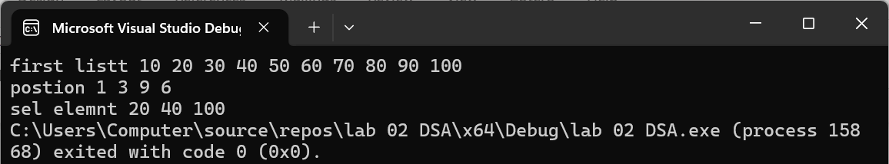
Task 3: List Intersection & Union [10]
Given two sorted lists, L1 and L2, write a function list_union to compute L1 ∪ L2 using only the basic list operations.
Code:
#include <iostream>
#include <list>
using namespace std;

list<int> list_union(list<int>& L1, list<int>& L2)
{
list<int> result;
list<int>::iterator it1 = L1.begin();
list<int>::iterator it2 = L2.begin();
while (it1 != L1.end() && it2 != L2.end())
{
if (*it1 < *it2)
{
result.push_back(*it1);
it1++;
}
else if (*it2 < *it1)
{
result.push_back(*it2);
it2++;
}
else
{
result.push_back(*it1);
it1++;
it2++;
}
}
while (it1 != L1.end())
{
result.push_back(*it1);
it1++;
}
while (it2 != L2.end())
{
result.push_back(*it2);
it2++;
}
return result;
}

int main()
{
list<int> L1, L2, result;
L1.push_back(2);
L1.push_back(3);
L1.push_back(5);
L1.push_back(7);
L2.push_back(2);
L2.push_back(3);
L2.push_back(6);
L2.push_back(9);
L2.push_back(10);

result = list_union(L1, L2);

cout << "union list ";
for (list<int>::iterator it = result.begin(); it != result.end(); it++)
{
cout << *it << " ";
}

return 0;
}
Output:
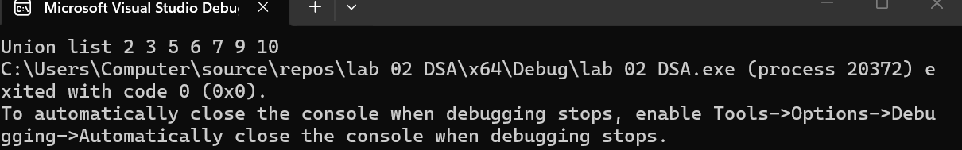

Singly Linked List Tasks
Task 1: Find Maximum [10]
Create header file for Node class and implement Node class in C++. Implement SingleLinkedList class and respective methods / functions in header file.
Code:#include <iostream>
using namespace std;

class Node
{
public:
int data;
Node* next;

Node(int value)
{
data = value;
next = NULL;
}
};
class SingleLinkedList
{
private:
Node* head;
public:
SingleLinkedList()
{
head = NULL;
}

void insert(int value)
{
Node* newNode = new Node(value);
if (head == NULL)
{
head = newNode;
}
else
{
Node* temp = head;
while (temp->next != NULL)
{
temp = temp->next;
}
temp->next = newNode;
}
}
int findMax()
{
if (head == NULL)
{
cout << "List is empty" << endl;
return -1;
}
int max = head->data;
Node* temp = head;
while (temp != NULL)
{
if (temp->data > max)
{
max = temp->data;
}
temp = temp->next;
}
return max;
}
void display()
{
Node* temp = head;
while (temp != NULL)
{
cout << temp->data << " -";
temp = temp->next;
}
cout << "NULL" << endl;
}
};
int main()
{
SingleLinkedList list;
list.insert(10);
list.insert(25);
list.insert(5);
list.insert(40);
list.insert(15);
cout << "list";
list.display();
cout << "Max value" << list.findMax() << endl;
return 0;
}
Output:
